Find the surface area and volume of these 2 prisms
Prism 1:
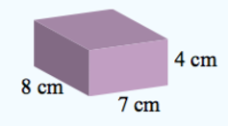

Prism 2:
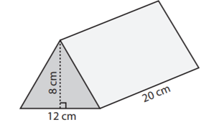

Find the surface area and volume of these 2 prisms
Prism 1:
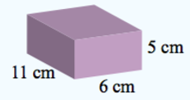

Prism 2:
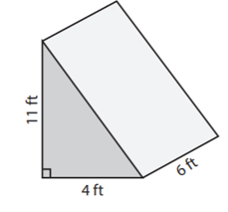

Find the surface area and volume of these 2 prisms
Prism 1:
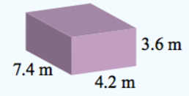

Prism 2:
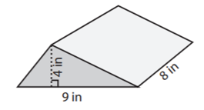

Find the surface area and volume of these 2 prisms
Prism 1:
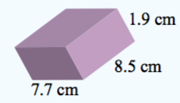

Prism 2:
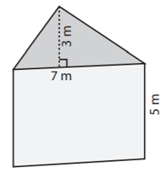

Find the surface area and volume of these 2 prisms
Prism 1:
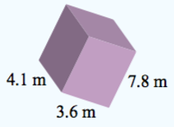

Prism 2:
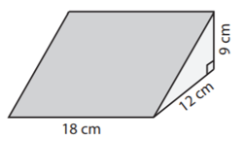

Find the surface area and volume of these 2 prisms
Prism 1:
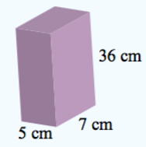

Prism 2:
